Validating Combined Vector Field Approach With Full Quadrotor Dynamics
Sikha Hotaª and Dheeraj^{b}*
ªProfessor, Department of Aerospace Engineering, Indian Institute of Technology Kharagpur, India
^{b}Student, Department of Aerospace Engineering, Indian Institute of Technology Kharagpur, India
*Communicating Author: Dheeraj (prajapatidheeraj25042004@gmail.com)

INTRODUCTION & OBJECTIVE
Autonomous unmanned aerial vehicles (UAVs) are increasingly employed in surveillance, reconnaissance, and environmental monitoring missions that demand precise path following under uncertain and dynamic conditions. The Combined Vector Field (CVF) approach proposed by Liang and Jia (2016) [1] provides a generalised mathematical framework for guiding UAVs along arbitrary twice-differentiable curves in both 2D and 3D spaces, using the Helmholtz decomposition of conservative and solenoidal vector fields to ensure convergence and smooth tangential motion. However, the validations have been limited to simplified kinematic models. This study aims to bridge the gap by integrating the CVF guidance law with the complete quadrotor dynamics model and robust control strategy. The quadrotor dynamics and Sliding Mode Control (SMC) law are developed following the methodology of Herrera et al. (2015) [2], enabling accurate attitude and position tracking under external disturbances. The primary objective of this work is to validate, through numerical simulation, the feasibility and effectiveness of the Combined Vector Field Approach when applied to a realistic quadrotor system, assessing its path-following accuracy, convergence, and robustness.

METHODS OF ANALYSIS
The simulation framework developed in this study integrates the Combined Vector Field (CVF) based guidance algorithm proposed in [1] with a complete quadrotor dynamic model and Sliding Mode Con- trol (SMC) structure described in [2].
The Combined Vector Field method generates continuous reference velocity directions for arbitrary twice-differentiable paths defined implicitly as $f (x, y) = 0$ for 2D paths, or $f (x, y, z) = 0$ and $g(x, y, z) = 0$ for 3D paths. The conservative and solenoidal vector fields are computed and combined as described in [1], given by
$v_{d} = -V_{g} tanh \left(κr\right)v_{c} + sV_{g} sech\left(κr\right)v_{s}$ (1)
where, $V_{g}$ is ground speed, $v_{c}$ and $v_{s}$ are normalized, conservative, and solenoidal vector fields, $r$ is the indirect measure of the distance from the desired curve defined by $f = 0$ and/or $g = 0$ $(r = f$ or $r=\sqrt{f 2 + g2} )$, $s(= ±1)$ determines the direction of the solenoidal vector field (clockwise or anticlockwise). And $κ$ is the tunable parameter that adjusts the rate of convergence. This formulation ensures a smooth, continuous, and feasible guidance vector field that guarantees asymptotic convergence to the desired path while maintaining tangential motion along it.
A proportional derivative (PD) saturated controller, incorporating limits on maximum course and climb rates, is employed to align the vehicle’s orientation with the CVF-generated reference directions. The resulting kinematic variables are then used as desired inputs for the quadrotor simulation developed following [2], where the Sliding Mode Controller provides robustness against disturbances and model uncertainties.

RESULTS
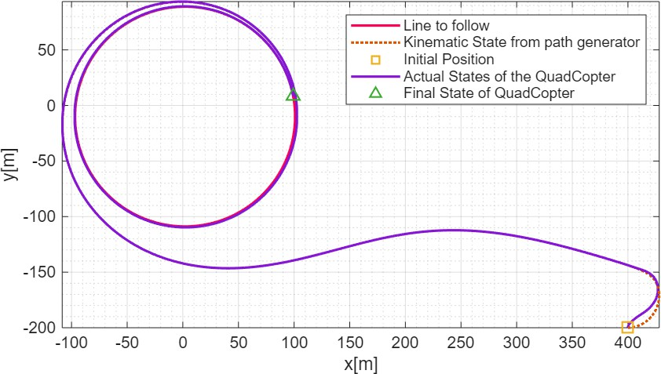
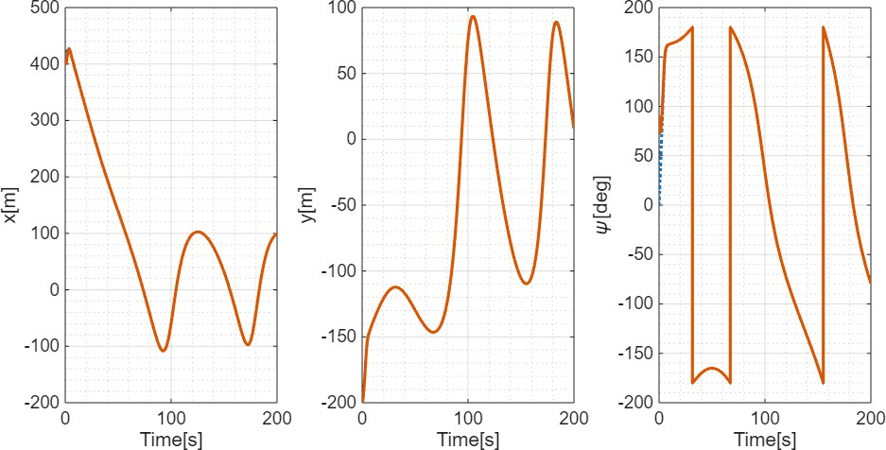
  - Simulating for the 2D circular curve given by $f (x, y) = {\left(x - 2\right)}^{2} + {\left(y + 10\right)}^{2} - 9775$, with parameters as initial position $[400, -200]m$, initial course angle $π/2 rad$, constant air speed, $v_{a} = 10m/s$, wind speed $w = [3, 4]m/s$, $s = +1$, vector field convergence parameter, $κ = 5$ and maximum course rate is $0.5rad/s$.
2
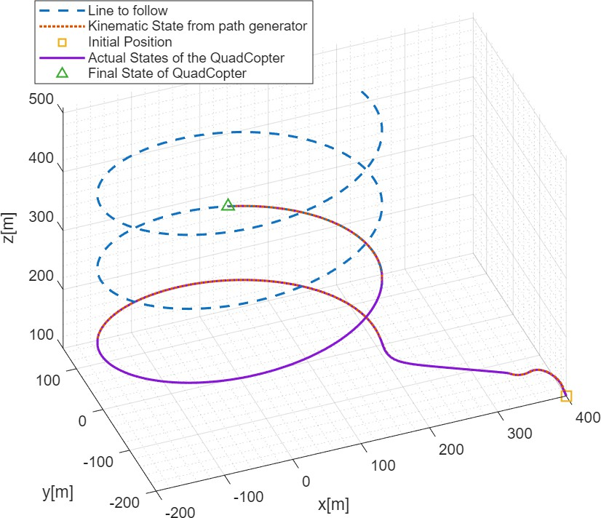
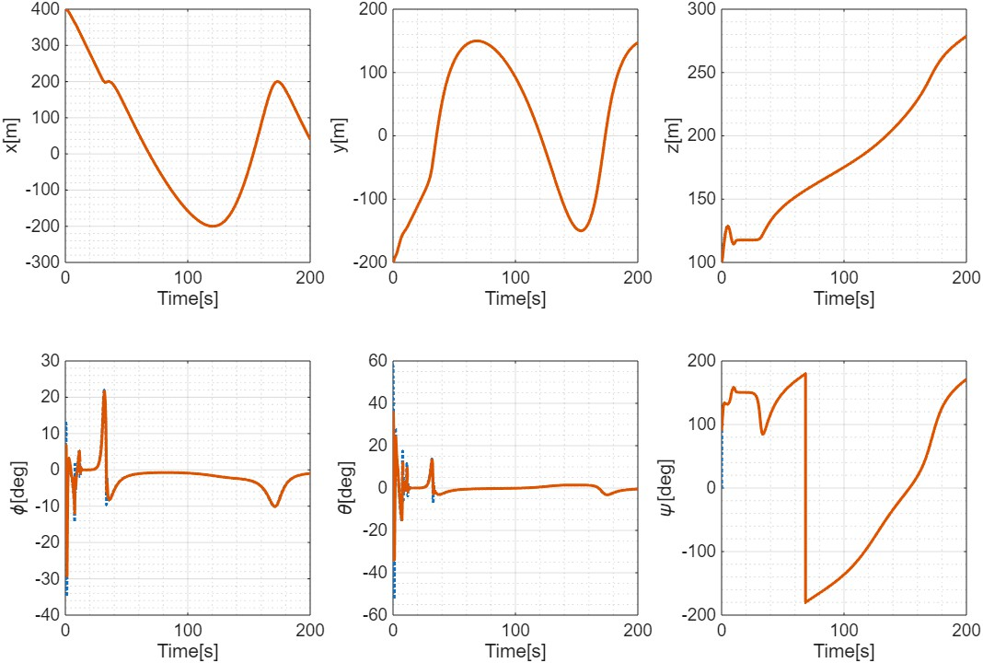
  - Simulating for the 3D inclined star curve given by, $f\left(x, y, z\right)=x-200\cos\left(z/20\right)$ and$g\left(x, y,z\right)=y-150\sin{(z/20)}$ with all other same parameters specified for the 2D case, with additional/updated parameters such as initial position $[-400, -200, 100]m$, initial climb angle $π/4 rad$, maximum climb rate, $0.3rad/s$, maximum allowable roll and pitch angle for the quadrotor, $π/3 rad$.
20
3

CONCLUSIONS
The numerical simulations demonstrate that the Combined Vector Field (CVF) guidance law, when inte- grated with Sliding Mode Control (SMC) and full quadrotor dynamics, achieves accurate path following for both 2D circular curves and 3D helical curves in a reasonable time. Although, as mentioned in [1], the main limitation of this approach is that the UAV might diverge or take too much time if the residual values of the intersecting function surfaces ($f (x, y, z)$ and $g(x, y, z)$) are not same order of magnitude; also, different curves require different convergence gain $κ$ (as seen in the above figures). The future work can be extended to have fixed-time convergence to the specified curve and can also be used to guide the UAV swarm.

REFERENCES
- Y. Liang and Y. Jia, “Combined vector field approach for 2d and 3d arbitrary twice differentiable curved path following with constrained uavs,” Journal of Intelligent & Robotic Systems, vol. 83, no. 1-4, pp. 133–160, 2016.
- M. Herrera, W. O. Chamorro, A. P. Go´mez, and O. Camacho, “Sliding mode control: An approach to control a quadrotor,” in 2015 IEEE Andean Country Congress (ANDESCON), 2015.

